## Equivalence Testing with Discrete Value (Black Box)

## Test Case and Results

### Invalid Case for Register Page

Input Parameters: Name , Email , Password , Re-enter Password

| No. | Name | Email | Password | Re-Enter Password | Expected Output | Actual Output | Pass / Fail ? |
| --- | --- | --- | --- | --- | --- | --- | --- |
| 1. | OJJ | random.sg | 123Random! | 123Random! | “Please include an ‘@’ in the email address.’input’ is missing an “@” | “Please include an ‘@’ in the email address. ‘random.sg’ us missing an “@” | Pass |
| 2. | OJJ | random@ | 123Random! | 123Random! | “Please enter a part following ‘@’,’input@’ is incomplete.” | “Please enter a park following ‘@’, ‘random@’ is incomplete.” | Pass |
| 3. | OJJ | random@gmail.com | 123Random  (no special character) | 123Random | Password must be between 8 and 20 characters, include at least 1 uppercase letter, 1 lowercase letter, 1 number, and 1 special character. | Password must be between 8 and 20 characters, include at least 1 uppercase letter, 1 lowercase letter, 1 number, and 1 special character. | Pass |
| 4 | OJJ | random@gmail.com | Randommm!  (no number) | Randommm! | Password must be between 8 and 20 characters, include at least 1 uppercase letter, 1 lowercase letter, 1 number, and 1 special character. | Password must be between 8 and 20 characters, include at least 1 uppercase letter, 1 lowercase letter, 1 number, and 1 special character. | Pass |
| 5. | OJJ | random@gmail.com | Rand12!  (below 8 char) | Random | Password must be between 8 and 20 characters, include at least 1 uppercase letter, 1 lowercase letter, 1 number, and 1 special character. | Password must be between 8 and 20 characters, include at least 1 uppercase letter, 1 lowercase letter, 1 number, and 1 special character. | Pass |
| 6. | OJJ | random@gmail.com | Randommmmmmmmmmmmmmm12!  (above 20 char) | Randommmmmmmmmmmmmmmmm | Password must be between 8 and 20 characters, include at least 1 uppercase letter, 1 lowercase letter, 1 number, and 1 special character. | Password must be between 8 and 20 characters, include at least 1 uppercase letter, 1 lowercase letter, 1 number, and 1 special character. | Pass |
| 7. | OJJ | random@gmail.com | random123!  (no uppercaser) | random123! | Password must be between 8 and 20 characters, include at least 1 uppercase letter, 1 lowercase letter, 1 number, and 1 special character. | Password must be between 8 and 20 characters, include at least 1 uppercase letter, 1 lowercase letter, 1 number, and 1 special character. | Pass |
| 8. | OJJ | random@gmail.com | RANDOM123!  (no lowercaser) | RANDOM123! | Password must be between 8 and 20 characters, include at least 1 uppercase letter, 1 lowercase letter, 1 number, and 1 special character. | Password must be between 8 and 20 characters, include at least 1 uppercase letter, 1 lowercase letter, 1 number, and 1 special character. | Pass |
| 9. | OJJ | random@gmail.com | 123Random! | 123Random  (password does not match) | Passwords do not match. Please make sure both password fields are identical. | Passwords do not match. Please make sure both password fields are identical. | Pass |
| 10. | Null | random@gmail.com | 123Random! | 123Random! | “Please fill out this field.” at “Name” input bar. | “Please fill out this field.” at “Name” input bar. | Pass |
| 11. | OJJ | Null | 123Random! | 123Random! | “Please fill out this field.” at “Email” input bar. | “Please fill out this field.” at “Email” input bar. | Pass |
| 12. | OJJ | random@gmail.com | Null | 123Random! | “Please fill out this field.” at “Password” input bar. | “Please fill out this field.” at “Password” input bar. | Pass |
| 13. | OJJ | random@gmail.com | 123Random! | Null | “Please fill out this field.” at “Re-Enter Password” input bar. | “Please fill out this field.” at “Re-Enter Password” input bar. |  |

### Valid Case for Register Page

Input Parameters: Name , Email , Password , Re-enter Password

| No. | Name | Email | Password | Re-Enter Password | Expected Output | Actual Output | Pass / Fail ? |
| --- | --- | --- | --- | --- | --- | --- | --- |
| 1. | OJJ | random@gmail.com | 123Random! | 123Random! | Redirected to Login Page | Redirected to Login Page | Pass |
| 2. | THR | random@yahoo.com.sg | 456rAndom@ | 456rAndom@ | Redirected to Login Page | Redirected to Login Page | Pass |
| 3. | YF | NotRandom@hotmail.com | RANDOm$789 | RANDOm$789 | Redirected to Login Page | Redirected to Login Page | Pass |

### 

### 

### Invalid Case for Login Page

Input Parameters: Email , Password

| No. | Email | Password | Expected Output | Actual Output | Pass / Fail ? |
| --- | --- | --- | --- | --- | --- |
| 1. | random.sg | 123Random! | “Please include an ‘@’ in the email address.’input’ us missing an “@” | “Please include an ‘@’ in the email address. random.sg is missing an “@” | Pass |
| 2. | random@ | 123Random! | “Please enter a part following ‘@’,’input@’ is incomplete.” | “Please enter a part following ‘@’, ‘random@’ is incomplete.” | Pass |
| 3. | Null | 123Random! | “Please fill out this field.”  At “Email” input bar | “Please fill out this field.”  At “Email” input bar | Pass |
| 4. | random@gmail.com | 123Random  (Wrong Password) | “Password Incorrect” | “Password Incorrect” | Pass |
| 5. | random@gmail.com | Null | “Please fill out this field.”  at “Password” input bar | “Please fill out this field.”  at “Password” input bar | Pass |
| 6. | random@gmail  (email not in database) | 123Random! | “No user with that email” | “No user with that email” | Pass |

### 

### Valid Case for Login Page

Input Parameters: Email , Password

| No. | Email | Password | Expected Output | Actual Output | Pass / Fail ? |
| --- | --- | --- | --- | --- | --- |
| 1. | random@gmail.com | 123Random! | Redirected to UserMapView | Redirected to UserMapView | Pass |
| 2. | random@yahoo.com.sg | 456rAndom@ | Redirected to UserMapView | Redirected to UserMapView | Pass |
| 3. | NotRandom@hotmail.com | RANDOm$789 | Redirected to UserMapView | Redirected to UserMapView | Pass |

### Valid Case for Guest

Input Parameters: User Click

| No. | Dk what to put here?? | Expected Output | Actual Output | Pass / Fail ? |
| --- | --- | --- | --- | --- |
| 1. | User Click “Continue as Guest” | Redirected to UserMapView | Redirected to UserMapView | Pass |

### 

### Invalid Case for ForgetPassword

Input Parameters: Email

| No. | Email | Expected Output | Actual Output | Pass / Fail ? |
| --- | --- | --- | --- | --- |
| 1. | random.sg | “Please include an ‘@’ in the email address.’input’ us missing an “@” | “Please include an ‘@’ in the email address. random.sg is missing an “@” | Pass |
| 2. | random@ | “Please enter a part following ‘@’,’input@’ is incomplete.” | “Please enter a part following ‘@’, ‘random@’ is incomplete.” | Pass |
| 4. | null | “Please fill out this field.”  At “Email” input bar | “Please fill out this field.”  At “Email” input bar | Pass |

### Valid Case for ForgetPassword

Input Parameters: Email

| No. | Email | Expected Output | Actual Output | Pass / Fail ? |
| --- | --- | --- | --- | --- |
| 1. | random@gmail.com | Redirected to ResetPasswordPage | Redirected to ResetPasswordPage | Pass |

### Invalid Case for ResetPassword

Input Parameters: OTP, New Password , Confirm Password

| No. | OTP | New Password | Confirm Password | Expected Output | Actual Output | Pass / Fail ? |
| --- | --- | --- | --- | --- | --- | --- |
| 1. | okqo1N  (Wrong OTP) | 123Random@ | 123Random@ | “OTP incorrect“ | “OTP incorrect“ | Pass |
| 2. | okqo1N  (OTP Expired) | 123Random@ | 123Random@ | Redirected back to ForgetPasswordPage  “Your OTP has expired. Please request a new one.” | Redirected back to ForgetPasswordPage  “Your OTP has expired. Please request a new one.” | Pass |
| 3. | Null | 123Random@ | 123Random@ | “Please fill out this field.”  At “OTP” input bar | “Please fill out this field.”  At “OTP” input bar | Pass |
| 4. | SSJteT | 1234Random  (no special character) | 1234Random | “Password must be between 8 and 20 characters, include at least 1 uppercase letter, 1 lowercase letter, 1 number, and 1 special character.” | “Password must be between 8 and 20 characters, include at least 1 uppercase letter, 1 lowercase letter, 1 number, and 1 special character.” | Pass |
| 5. | SSJteT | Randommm@  (no number) | Randommm@ | Password must be between 8 and 20 characters, include at least 1 uppercase letter, 1 lowercase letter, 1 number, and 1 special character. | Password must be between 8 and 20 characters, include at least 1 uppercase letter, 1 lowercase letter, 1 number, and 1 special character. | Pass |
| 6. | SSJteT | Rand12!  (below 8 char) | Rand12! | Password must be between 8 and 20 characters, include at least 1 uppercase letter, 1 lowercase letter, 1 number, and 1 special character. | Password must be between 8 and 20 characters, include at least 1 uppercase letter, 1 lowercase letter, 1 number, and 1 special character. | Pass |
| 7. | SSJteT | Randommmmmmmmmmmmmmm12@  (above 20 char) | Randommmmmmmmmmmmmmm12@ | Password must be between 8 and 20 characters, include at least 1 uppercase letter, 1 lowercase letter, 1 number, and 1 special character. | Password must be between 8 and 20 characters, include at least 1 uppercase letter, 1 lowercase letter, 1 number, and 1 special character. | Pass |
| 8. | SSJteT | random123@  (no uppercaser) | random123@ | Password must be between 8 and 20 characters, include at least 1 uppercase letter, 1 lowercase letter, 1 number, and 1 special character. | Password must be between 8 and 20 characters, include at least 1 uppercase letter, 1 lowercase letter, 1 number, and 1 special character. | Pass |
| 9. | SSJteT | 123Random@ | 123Random! | “Passwords do not match. Please make sure both password fields are identical.” | “Passwords do not match. Please make sure both password fields are identical.” | Pass |
| 10. | SSJteT | Null | 123Random@ | “Please fill out this field.”  at “New Password” input bar | “Please fill out this field.”  at “New Password” input bar | Pass |
|  | SSJteT | 123Random@ | Null | “Please fill out this field.”  at “Confirm Password” input bar | “Please fill out this field.”  at “Confirm Password” input bar | Pass |

### Valid Case for ResetPassword

Input Parameters: OTP, New Password , Confirm Password

| No. | OTP | New Password | Confirm Password | Expected Output | Actual Output | Pass / Fail ? |
| --- | --- | --- | --- | --- | --- | --- |
| 1. | SSJteT | 123Random@ | 123Random@ | Redirected to SuccessResetPasswordPage | Redirected to SuccessResetPasswordPage | Pass |

### 

### Invalid Case for SearchAndSelectDestination

Input Parameters: User input address/postal code

| No. | Search Bar | User Select | Expected Output | Actual Output | Pass / Fail ? |
| --- | --- | --- | --- | --- | --- |
| 2. | Null | Nothing for user to select | Null | Null | Pass |
| 3. | 991854  (postal code don't exist) | User presses the search button | “No results found.” drop-down error box. | “No results found.” drop-down error box. | Pass |

### Valid Case for SearchAndSelectDestination

Input Parameters: User input address/postal code

| No. | Search Bar | User Select | Expected Output | Actual Output | Pass / Fail ? |
| --- | --- | --- | --- | --- | --- |
| 1. | “woodlands mrt” | “Woodlands Mrt Station (NS9)” | Car Park Markers of nearby car parks within 500 meters of destination pops up.  Parking Lots Found List shows a list of nearby car park details  User History is shown if there if any | Car Park Markers of nearby car parks within 500 meters of destination pops up.  Parking Lots Found List shows a list of nearby car park details  User History is shown if there is any | Pass |
| 2. | “Jurong point” | “Jurong Point” | Car Park Markers of nearby car parks within 500 meters of destination pops up.  Parking Lots Found List shows a list of nearby car park details  User History is shown if there if any | Car Park Markers of nearby car parks within 500 meters of destination pops up.  Parking Lots Found List shows a list of nearby car park details  User History is shown if there is any | Pass |
| 3. | “520716”  (postal code for Block 716 Tampines Street 71) | User press search icon | Car Park Markers of nearby car parks within 500 meters of destination pops up.  Parking Lots Found List shows a list of nearby car park details  User History is shown if there if any | Car Park Markers of nearby car parks within 500 meters of destination pops up.  Parking Lots Found List shows a list of nearby car park details  User History is shown if there is any | Pass |
| 4. | “560106” (Blk 106 Ang Mo Kio Avenue 4) | User press search icon | Car Park Markers of nearby car parks within 500 meters of destination pops up.  Parking Lots Found List shows a list of nearby car park details  User History is shown if there if any | Car Park Markers of nearby car parks within 500 meters of destination pops up.  Parking Lots Found List shows a list of nearby car park details  User History is shown if there is any | Pass |

### Invalid Case for SelectCarpark

Input Parameters: User click to select

| No. | User Select Car Park from Parking Lots Found List | Expected Output | Actual Output | Pass / Fail ? |
| --- | --- | --- | --- | --- |
| 1. | User could not find car park of choice | Car Park Markers of nearby car parks within 500 meters of destination pops up.  Parking Lots Found List shows a list of nearby car park details  User History is shown if there if any | Car Park Markers of nearby car parks within 500 meters of destination pops up.  Parking Lots Found List shows a list of nearby car park details  User History is shown if there if any | Pass |

### 

### Valid Case for SelectCarpark

Input Parameters: User click to select

| No. | User Select Car Park from Parking Lots Found List | Expected Output | Actual Output | Pass / Fail ? |
| --- | --- | --- | --- | --- |
| 1. | “Carpark WCC: 900 South Woodlands Dr” | Show route from user destination to car park  Selected car park shown in recent history | Show route from user destination to car park  Selected car park shown in recent history | Pass |
| 2. | “Carpark BL24: BLK 237 Boon Lay Drive” | Show route from user destination to car park  Selected car park shown in recent history | Show route from user destination to car park  Selected car park shown in recent history | Pass |
| 3. | “Carpark NT1: BLK 601 Tampines Avenue 9” | Show route from user destination to car park  Selected car park shown in recent history | Show route from user destination to car park  Selected car park shown in recent history | Pass |

## White Box Testing

### Control flow for ForgetPassword & ResetPassword Test Case

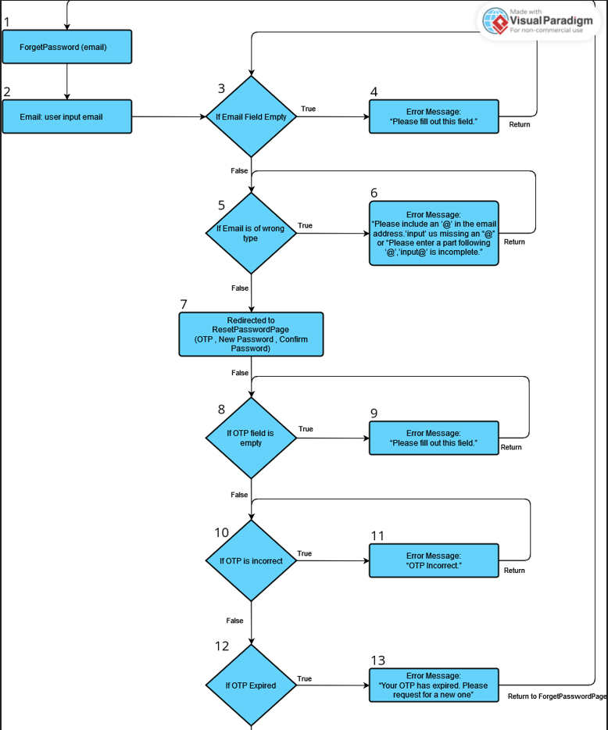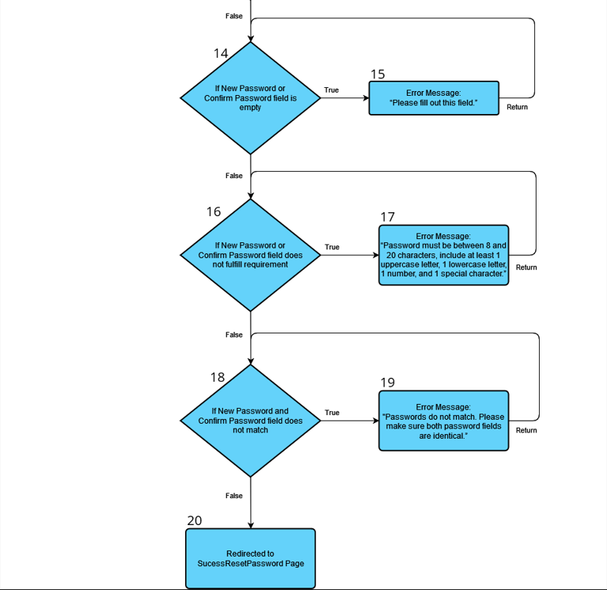

Cyclomatic Complexity = |Decision points| + 1 = 9

Basis Paths for ForgetPassword & ResetPassword

1. Baseline path: 1, 2, 3, 5, 7, 8, 10, 12, 14, 16, 18, 20
2. Basis path 1: 1, 2, 4, 5, 7, 8, 10, 12, 14, 16, 18, 20
3. Basis path 2: 1, 2, 5, 6, 7, 8, 10, 12, 14, 16, 18, 20
4. Basis path 3: 1, 2, 5, 7, 8, 9, 10, 12, 14, 16, 18, 20
5. Basis path 4: 1, 2, 5, 7, 8, 10, 11, 12, 14, 16, 18, 20
6. Basis path 5: 1, 2, 5, 7, 8, 10, 12, 13, 14, 16, 18, 20
7. Basis path 6: 1, 2, 5, 7, 8, 10, 12, 14, 15, 16, 18, 20
8. Basis path 7: 1, 2, 5, 7, 8, 10, 12, 14, 16, 17, 18, 20
9. Basis path 8: 1, 2, 5, 7, 8, 10, 12, 14, 16, 18, 19, 20

| No. | Email | OTP | New Password | Confirm Password | Expected Output | Actual Output | Pass / Fail ? |
| --- | --- | --- | --- | --- | --- | --- | --- |
| 1. | random@gmail.com | SSJteT | 123Random@ | 123Random@ | Redirected to SuccessResetPasswordPage | Redirected to SuccessResetPasswordPage | Pass |
| 2.. | null | null | null | null | “Please fill out this field.”  At “Email” input bar | “Please fill out this field.”  At “Email” input bar | Pass |
| 3. | random@ | null | null | null | “Please include an ‘@’ in the email address.’input’ us missing an “@”  or  “Please enter a part following ‘@’,’input@’ is incomplete.” | “Please include an ‘@’ in the email address.’input’ us missing an “@”  or  “Please enter a part following ‘@’,’input@’ is incomplete.” | Pass |
| 4. | random@gmail.com | Null | 123Random@ | 123Random@ | “Please fill out this field.”  At “OTP” input bar | “Please fill out this field.”  At “OTP” input bar | Pass |
| 5. | random@gmail.com | test12 | 123Random@ | 123Random@ | “OTP incorrect“ | “OTP incorrect“ | Pass |
| 6. | random@gmail.com | SSJteT  (OTP expired) | 123Random@ | 123Random@ | Redirected back to ForgetPasswordPage  “Your OTP has expired. Please request a new one.” | Redirected back to ForgetPasswordPage  “Your OTP has expired. Please request a new one.” | Pass |
| 7. | random@gmail.com | SSJteT | Null | 123Random@ | “Please fill out this field.”  At “New Password” input bar | “Please fill out this field.”  At “New Password” input bar | Pass |
| 8. | random@gmail.com | SSJteT | 123Random  (no symbol) | 123Random  (no symbol) | Password must be between 8 and 20 characters, include at least 1 uppercase letter, 1 lowercase letter, 1 number, and 1 special character. | Password must be between 8 and 20 characters, include at least 1 uppercase letter, 1 lowercase letter, 1 number, and 1 special character. | Pass |
| 9. | random@gmail.com | SSJteT | 123Random@ | random123@  (Password don't match) | “Passwords do not match. Please make sure both password fields are identical.” | “Passwords do not match. Please make sure both password fields are identical.” | Pass |

### 

### 

### 

### 

### 

### 

### 

### 

### 

### 

### 

### Control Flow for Filter Test Case

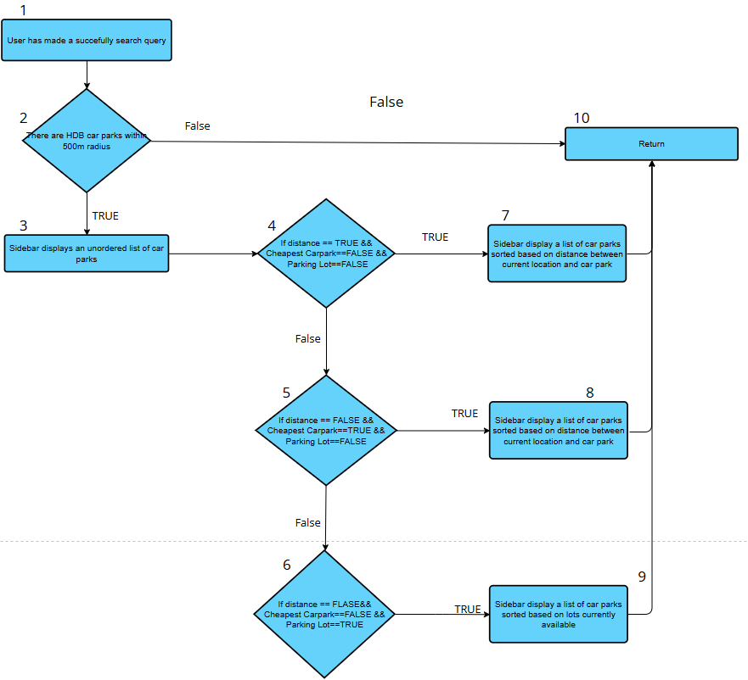

Filter Test Case Paths

Path #1: 1, 2, 10

Path #2: 1, 2, 3, 4, 7, 10 (when user filters by Distance)

Path #3: 1, 2, 3, 5, 8, 10 (when user filters by Cheapest Car Park)

Path #4: 1, 2, 3, 6, 9, 10 (when user filters by lots currently available)

Test Case

1. No car park nearby
2. User filters by Distance
3. User filters by Cheapest Car Park
4. User filters by lots currently available